* **Return the first name, last name and city of all customers who live in Canada. Order the results first by the last then by the first name**.

*create table customer_c*

*(*

*select e.first_name,e.last_name,f.city,f.country*

*from sakila.customer e left join*

*(select c.address_id,d.\**

*from sakila.address c,*

*(select distinct a.city_id,b.country_id,b.country,a.city*

*from sakila.city a,sakila.country b*

*where a.country_id=b.country_id*

*order by country*

*) d*

*where c.city_id=d.city_id*

*) f*

*on e.address_id=f.address_id*

*order by e.last_name,e.first_name*

*);*

1. **Order by last_name**

*select first_name,last_name,country*

*from customer_c*

*where country="Canada"*

*order by last_name;*

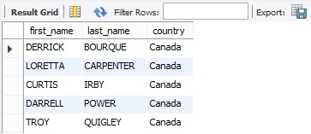

1. **Order by first_name**

*select first_name,last_name,country*

*from customer_c*

*where country="Canada"*

*order by first_name;*

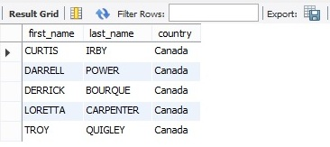

* **How many customers are from Brazil?**

*select count(*) from customer_c where country="Brazil";*

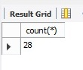

* **Return the "popular countries"? For each such country, return its name and its correspond number of customers. Order the result by the number of customers (descending).**

*select country,count(*)*

*from customer_c*

*group by country*

*having count(*)>20*

*order by count(*) desc;*

